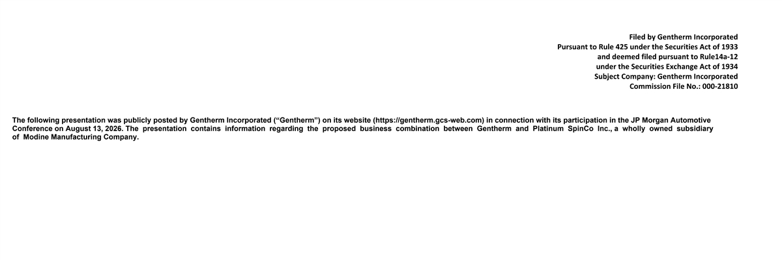
Filed by Gentherm Incorporated Pursuant to Rule 425 under the Securities Act of 1933 and deemed filed pursuant to Rule14a-12 under the Securities Exchange Act of 1934 Subject Company: Gentherm Incorporated Commission File No.: 000-21810 The following presentation was publicly posted by Gentherm Incorporated (“Gentherm”) on its website (https://gentherm.gcs-web.com) in connection with its participation in the JP Morgan Automotive Conference on August 13, 2026. The presentation contains information regarding the proposed business combination between Gentherm and Platinum SpinCo Inc., a wholly owned subsidiary of Modine Manufacturing Company.

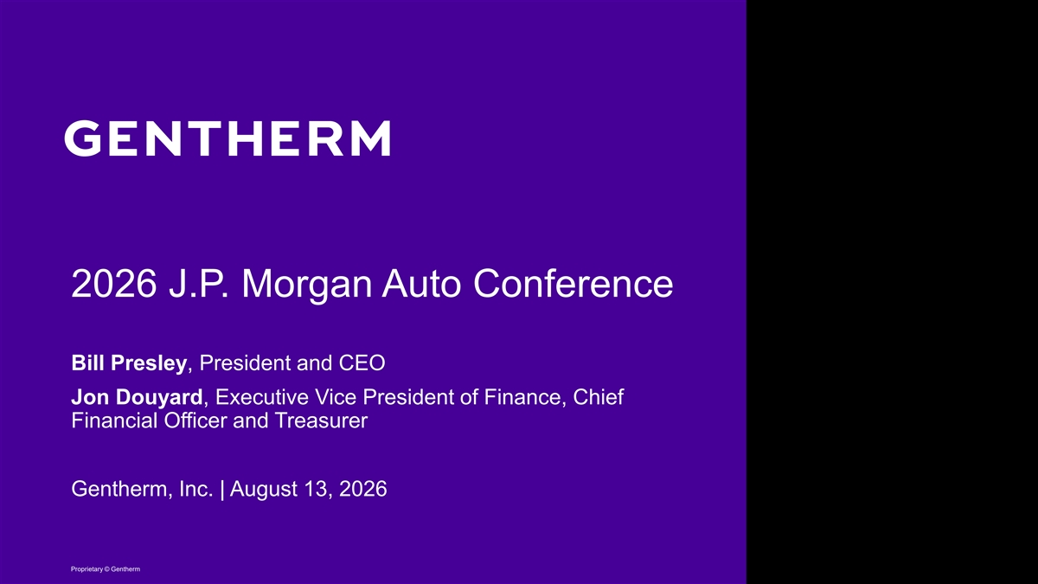
2026 J.P. Morgan Auto Conference Bill Presley, President and CEO Jon Douyard, Executive Vice President of Finance, Chief Financial Officer and Treasurer Gentherm, Inc. | August 13, 2026 Proprietary © Gentherm

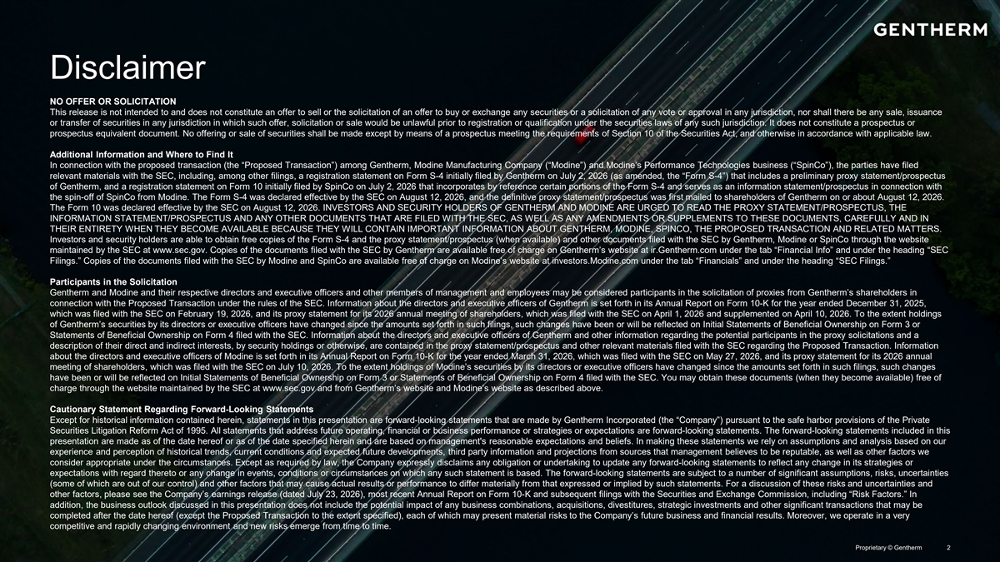
Disclaimer NO OFFER OR SOLICITATION This release is not intended to and does not constitute an offer to sell or the solicitation of an offer to buy or exchange any securities or a solicitation of any vote or approval in any jurisdiction, nor shall there be any sale, issuance or transfer of securities in any jurisdiction in which such offer, solicitation or sale would be unlawful prior to registration or qualification under the securities laws of any such jurisdiction. It does not constitute a prospectus or prospectus equivalent document. No offering or sale of securities shall be made except by means of a prospectus meeting the requirements of Section 10 of the Securities Act, and otherwise in accordance with applicable law. Additional Information and Where to Find It In connection with the proposed transaction (the “Proposed Transaction”) among Gentherm, Modine Manufacturing Company (“Modine”) and Modine’s Performance Technologies business (“SpinCo”), the parties have filed relevant materials with the SEC, including, among other filings, a registration statement on Form S-4 initially filed by Gentherm on July 2, 2026 (as amended, the “Form S-4”) that includes a preliminary proxy statement/prospectus of Gentherm, and a registration statement on Form 10 initially filed by SpinCo on July 2, 2026 that incorporates by reference certain portions of the Form S-4 and serves as an information statement/prospectus in connection with the spin-off of SpinCo from Modine. The Form S-4 was declared effective by the SEC on August 12, 2026, and the definitive proxy statement/prospectus was first mailed to shareholders of Gentherm on or about August 12, 2026. The Form 10 was declared effective by the SEC on August 12, 2026. INVESTORS AND SECURITY HOLDERS OF GENTHERM AND MODINE ARE URGED TO READ THE PROXY STATEMENT/PROSPECTUS, THE INFORMATION STATEMENT/PROSPECTUS AND ANY OTHER DOCUMENTS THAT ARE FILED WITH THE SEC, AS WELL AS ANY AMENDMENTS OR SUPPLEMENTS TO THESE DOCUMENTS, CAREFULLY AND IN THEIR ENTIRETY WHEN THEY BECOME AVAILABLE BECAUSE THEY WILL CONTAIN IMPORTANT INFORMATION ABOUT GENTHERM, MODINE, SPINCO, THE PROPOSED TRANSACTION AND RELATED MATTERS. Investors and security holders are able to obtain free copies of the Form S-4 and the proxy statement/prospectus (when available) and other documents filed with the SEC by Gentherm, Modine or SpinCo through the website maintained by the SEC at www.sec.gov. Copies of the documents filed with the SEC by Gentherm are available free of charge on Gentherm’s website at ir.Gentherm.com under the tab “Financial Info” and under the heading “SEC Filings.” Copies of the documents filed with the SEC by Modine and SpinCo are available free of charge on Modine’s website at investors.Modine.com under the tab “Financials” and under the heading “SEC Filings.” Participants in the Solicitation Gentherm and Modine and their respective directors and executive officers and other members of management and employees may be considered participants in the solicitation of proxies from Gentherm’s shareholders in connection with the Proposed Transaction under the rules of the SEC. Information about the directors and executive officers of Gentherm is set forth in its Annual Report on Form 10-K for the year ended December 31, 2025, which was filed with the SEC on February 19, 2026, and its proxy statement for its 2026 annual meeting of shareholders, which was filed with the SEC on April 1, 2026 and supplemented on April 10, 2026. To the extent holdings of Gentherm’s securities by its directors or executive officers have changed since the amounts set forth in such filings, such changes have been or will be reflected on Initial Statements of Beneficial Ownership on Form 3 or Statements of Beneficial Ownership on Form 4 filed with the SEC. Information about the directors and executive officers of Gentherm and other information regarding the potential participants in the proxy solicitations and a description of their direct and indirect interests, by security holdings or otherwise, are contained in the proxy statement/prospectus and other relevant materials filed with the SEC regarding the Proposed Transaction. Information about the directors and executive officers of Modine is set forth in its Annual Report on Form 10-K for the year ended March 31, 2026, which was filed with the SEC on May 27, 2026, and its proxy statement for its 2026 annual meeting of shareholders, which was filed with the SEC on July 10, 2026. To the extent holdings of Modine’s securities by its directors or executive officers have changed since the amounts set forth in such filings, such changes have been or will be reflected on Initial Statements of Beneficial Ownership on Form 3 or Statements of Beneficial Ownership on Form 4 filed with the SEC. You may obtain these documents (when they become available) free of charge through the website maintained by the SEC at www.sec.gov and from Gentherm’s website and Modine’s website as described above. Cautionary Statement Regarding Forward-Looking Statements Except for historical information contained herein, statements in this presentation are forward-looking statements that are made by Gentherm Incorporated (the “Company”) pursuant to the safe harbor provisions of the Private Securities Litigation Reform Act of 1995. All statements that address future operating, financial or business performance or strategies or expectations are forward-looking statements. The forward-looking statements included in this presentation are made as of the date hereof or as of the date specified herein and are based on management's reasonable expectations and beliefs. In making these statements we rely on assumptions and analysis based on our experience and perception of historical trends, current conditions and expected future developments, third party information and projections from sources that management believes to be reputable, as well as other factors we consider appropriate under the circumstances. Except as required by law, the Company expressly disclaims any obligation or undertaking to update any forward-looking statements to reflect any change in its strategies or expectations with regard thereto or any change in events, conditions or circumstances on which any such statement is based. The forward-looking statements are subject to a number of significant assumptions, risks, uncertainties (some of which are out of our control) and other factors that may cause actual results or performance to differ materially from that expressed or implied by such statements. For a discussion of these risks and uncertainties and other factors, please see the Company’s earnings release (dated July 23, 2026), most recent Annual Report on Form 10-K and subsequent filings with the Securities and Exchange Commission, including “Risk Factors.” In addition, the business outlook discussed in this presentation does not include the potential impact of any business combinations, acquisitions, divestitures, strategic investments and other significant transactions that may be completed after the date hereof (except the Proposed Transaction to the extent specified), each of which may present material risks to the Company’s future business and financial results. Moreover, we operate in a very competitive and rapidly changing environment and new risks emerge from time to time. Proprietary © Gentherm 2

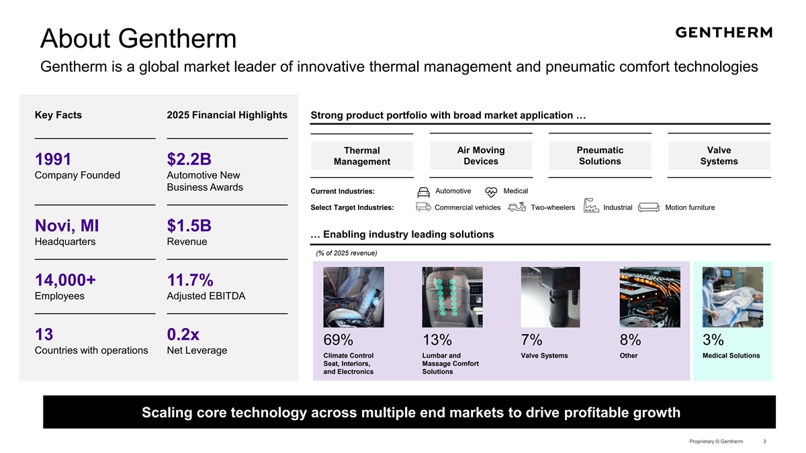
About Gentherm Gentherm is a global market leader of innovative thermal management and pneumatic comfort technologies Key Facts 2025 Financial Highlights Strong product portfolio with broad market application … Thermal Air Moving Pneumatic Valve Management Devices Solutions Systems 1991 $2.2B Company Founded Automotive New Business Awards Current Industries: Automotive Medical Select Target Industries: Commercial vehicles Two-wheelers Industrial Motion furniture Novi, MI $1.5B … Enabling industry leading solutions Headquarters Revenue (% of 2025 revenue) 14,000+ 11.7% Employees Adjusted EBITDA 13 0.2x 69% 13% 7% 8% 3% Countries with operations Net Leverage Climate Control Lumbar and Valve Systems Other Medical Solutions Seat, Interiors, Massage Comfort and Electronics Solutions Scaling core technology across multiple end markets to drive profitable growth Proprietary © Gentherm 3

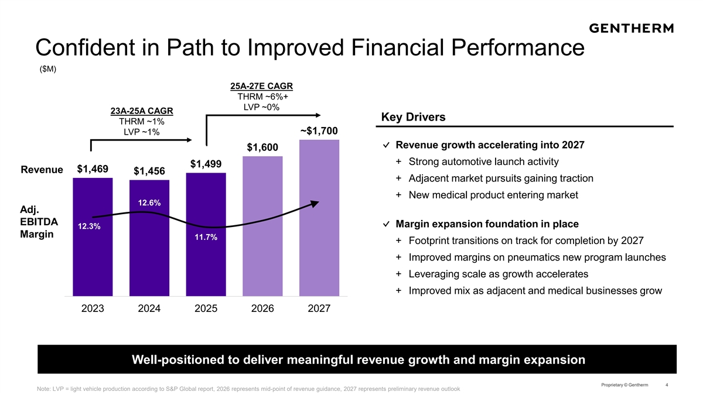
Confident in Path to Improved Financial Performance ($M) 25A-27E CAGR THRM ~6%+ LVP ~0% 23A-25A CAGR Key Drivers THRM ~1% ~$1,700 LVP ~1% ✓ Revenue growth accelerating into 2027 $1,600 + Strong automotive launch activity $1,499 $1,469 Revenue $1,456 + Adjacent market pursuits gaining traction + New medical product entering market 12.6% Adj. EBITDA ✓ Margin expansion foundation in place 12.3% Margin 11.7% + Footprint transitions on track for completion by 2027 + Improved margins on pneumatics new program launches + Leveraging scale as growth accelerates + Improved mix as adjacent and medical businesses grow 2023 2024 2025 2026 2027 Well-positioned to deliver meaningful revenue growth and margin expansion Proprietary © Gentherm 4 Note: LVP = light vehicle production according to S&P Global report, 2026 represents mid-point of revenue guidance, 2027 represents preliminary revenue outlook

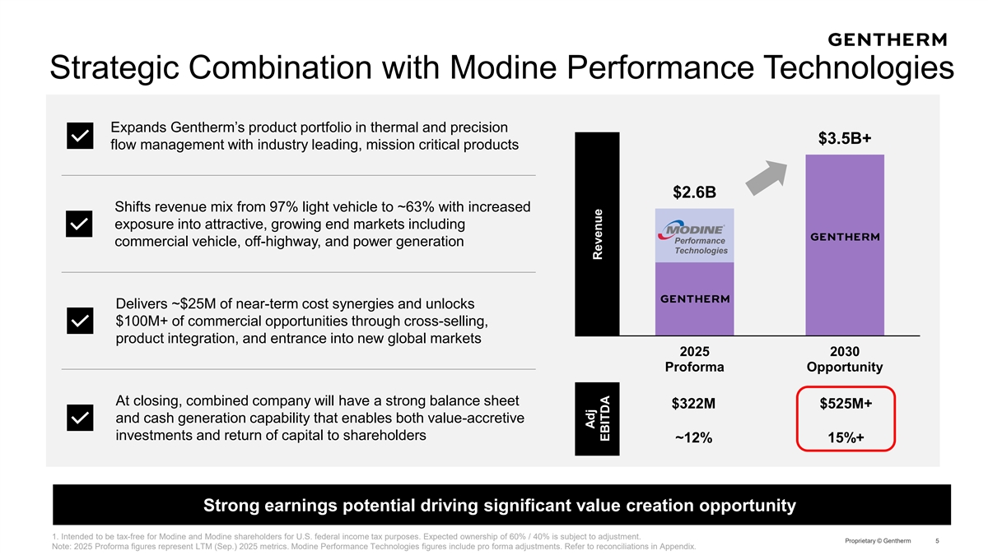
Strategic Combination with Modine Performance Technologies Expands Gentherm’s product portfolio in thermal and precision $3.5B+ flow management with industry leading, mission critical products $2.6B Shifts revenue mix from 97% light vehicle to ~63% with increased exposure into attractive, growing end markets including Performance commercial vehicle, off-highway, and power generation Technologies Delivers ~$25M of near-term cost synergies and unlocks $100M+ of commercial opportunities through cross-selling, product integration, and entrance into new global markets 2025 2030 Proforma Opportunity At closing, combined company will have a strong balance sheet $322M $525M+ and cash generation capability that enables both value-accretive investments and return of capital to shareholders ~12% 15%+ Strong earnings potential driving significant value creation opportunity 1. Intended to be tax-free for Modine and Modine shareholders for U.S. federal income tax purposes. Expected ownership of 60% / 40% is subject to adjustment. Proprietary © Gentherm 5 Note: 2025 Proforma figures represent LTM (Sep.) 2025 metrics. Modine Performance Technologies figures include pro forma adjustments. Refer to reconciliations in Appendix. Adj Revenue EBITDA

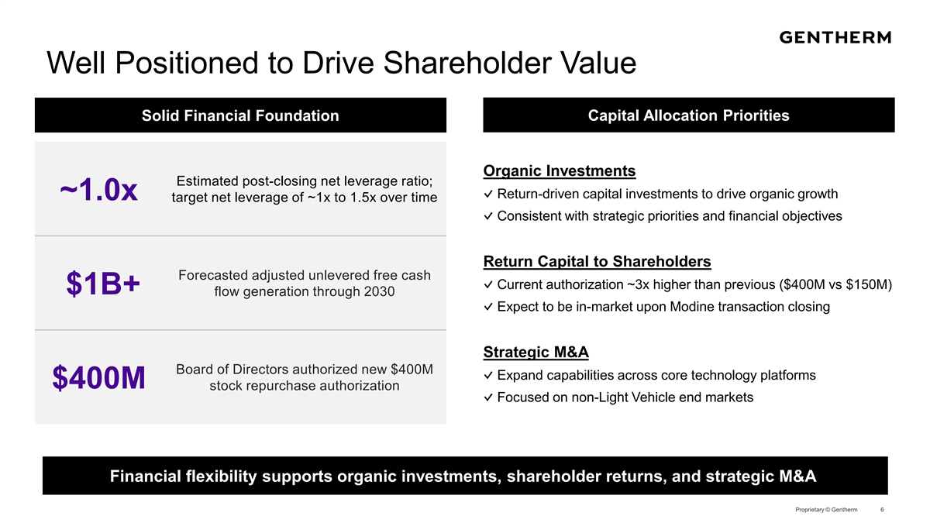
Well Positioned to Drive Shareholder Value Solid Financial Foundation Capital Allocation Priorities Organic Investments Estimated post-closing net leverage ratio; ✓ Return-driven capital investments to drive organic growth ~1.0x target net leverage of ~1x to 1.5x over time ✓ Consistent with strategic priorities and financial objectives Return Capital to Shareholders Forecasted adjusted unlevered free cash ✓ Current authorization ~3x higher than previous ($400M vs $150M) $1B+ flow generation through 2030 ✓ Expect to be in-market upon Modine transaction closing Strategic M&A Board of Directors authorized new $400M ✓ Expand capabilities across core technology platforms $400M stock repurchase authorization ✓ Focused on non-Light Vehicle end markets Financial flexibility supports organic investments, shareholder returns, and strategic M&A Proprietary © Gentherm 6

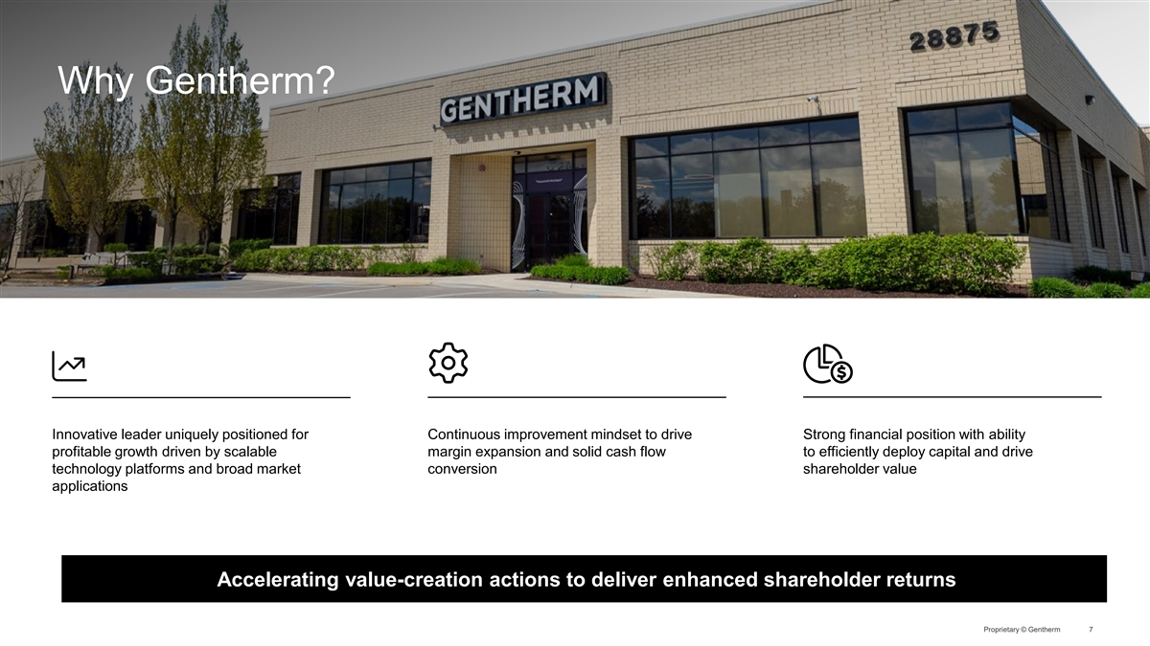
Why Gentherm? Innovative leader uniquely positioned for Continuous improvement mindset to drive Strong financial position with ability profitable growth driven by scalable margin expansion and solid cash flow to efficiently deploy capital and drive technology platforms and broad market conversion shareholder value applications Accelerating value-creation actions to deliver enhanced shareholder returns Proprietary © Gentherm 7


Appendix Proprietary © Gentherm

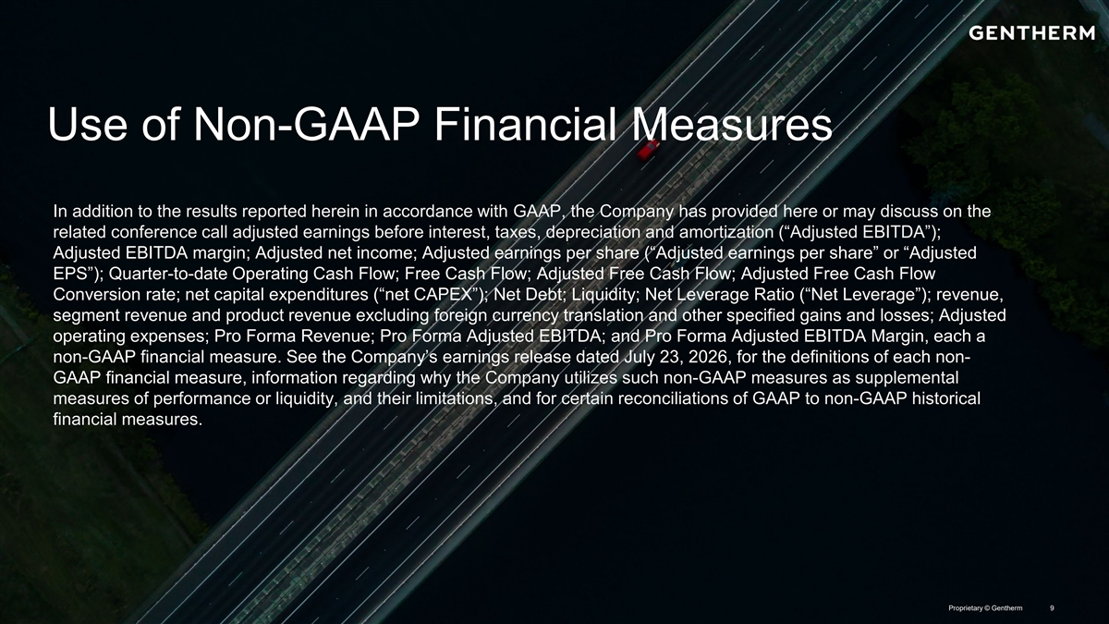
Use of Non-GAAP Financial Measures In addition to the results reported herein in accordance with GAAP, the Company has provided here or may discuss on the related conference call adjusted earnings before interest, taxes, depreciation and amortization (“Adjusted EBITDA”); Adjusted EBITDA margin; Adjusted net income; Adjusted earnings per share (“Adjusted earnings per share” or “Adjusted EPS”); Quarter-to-date Operating Cash Flow; Free Cash Flow; Adjusted Free Cash Flow; Adjusted Free Cash Flow Conversion rate; net capital expenditures (“net CAPEX”); Net Debt; Liquidity; Net Leverage Ratio (“Net Leverage”); revenue, segment revenue and product revenue excluding foreign currency translation and other specified gains and losses; Adjusted operating expenses; Pro Forma Revenue; Pro Forma Adjusted EBITDA; and Pro Forma Adjusted EBITDA Margin, each a non-GAAP financial measure. See the Company’s earnings release dated July 23, 2026, for the definitions of each non- GAAP financial measure, information regarding why the Company utilizes such non-GAAP measures as supplemental measures of performance or liquidity, and their limitations, and for certain reconciliations of GAAP to non-GAAP historical financial measures. Proprietary © Gentherm 9

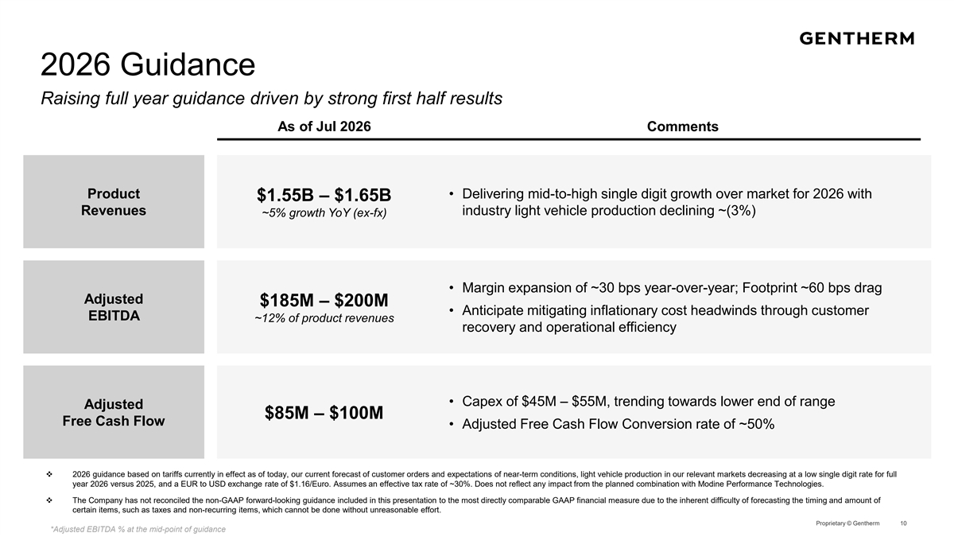
2026 Guidance Raising full year guidance driven by strong first half results As of Jul 2026 Comments Product • Delivering mid-to-high single digit growth over market for 2026 with $1.55B – $1.65B Revenues industry light vehicle production declining ~(3%) ~5% growth YoY (ex-fx) • Margin expansion of ~30 bps year-over-year; Footprint ~60 bps drag Adjusted $185M – $200M • Anticipate mitigating inflationary cost headwinds through customer EBITDA ~12% of product revenues recovery and operational efficiency • Capex of $45M – $55M, trending towards lower end of range Adjusted $85M – $100M Free Cash Flow • Adjusted Free Cash Flow Conversion rate of ~50% v 2026 guidance based on tariffs currently in effect as of today, our current forecast of customer orders and expectations of near-term conditions, light vehicle production in our relevant markets decreasing at a low single digit rate for full year 2026 versus 2025, and a EUR to USD exchange rate of $1.16/Euro. Assumes an effective tax rate of ~30%. Does not reflect any impact from the planned combination with Modine Performance Technologies. v The Company has not reconciled the non-GAAP forward-looking guidance included in this presentation to the most directly comparable GAAP financial measure due to the inherent difficulty of forecasting the timing and amount of certain items, such as taxes and non-recurring items, which cannot be done without unreasonable effort. Proprietary © Gentherm 10 *Adjusted EBITDA % at the mid-point of guidance

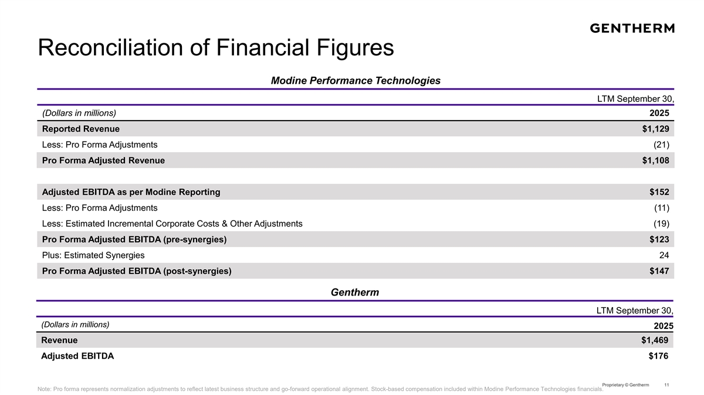
Reconciliation of Financial Figures Modine Performance Technologies LTM September 30, (Dollars in millions) 2025 Reported Revenue $1,129 Less: Pro Forma Adjustments (21) Pro Forma Adjusted Revenue $1,108 Adjusted EBITDA as per Modine Reporting $152 Less: Pro Forma Adjustments (11) Less: Estimated Incremental Corporate Costs & Other Adjustments (19) Pro Forma Adjusted EBITDA (pre-synergies) $123 Plus: Estimated Synergies 24 Pro Forma Adjusted EBITDA (post-synergies) $147 Gentherm LTM September 30, (Dollars in millions) 2025 Revenue $1,469 Adjusted EBITDA $176 Proprietary © Gentherm 11 Note: Pro forma represents normalization adjustments to reflect latest business structure and go-forward operational alignment. Stock-based compensation included within Modine Performance Technologies financials.

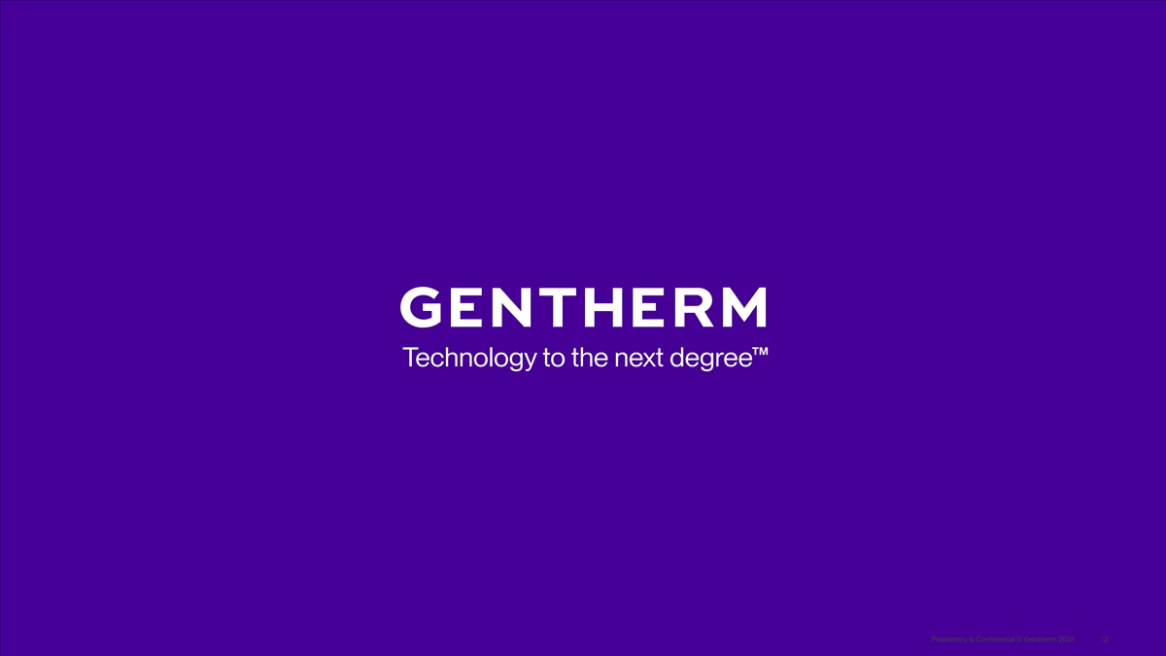
Proprietary & Confidential © Gentherm 2024 12

