Filed by Gentherm Incorporated
Pursuant to Rule 425 under the Securities Act of 1933
and deemed filed pursuant to Rule14a-12
under the Securities Exchange Act of 1934
Subject Company: Gentherm Incorporated
Commission File No.:000-21810
The following presentation was publicly posted by Gentherm Incorporated (“Gentherm”) on its website (https://gentherm.gcs-web.com) in connection with its second quarter 2026 financial results conference call held on July 23, 2026. The presentation contains information regarding the proposed business combination between Gentherm and Platinum SpinCo Inc., a wholly owned subsidiary of Modine Manufacturing Company.

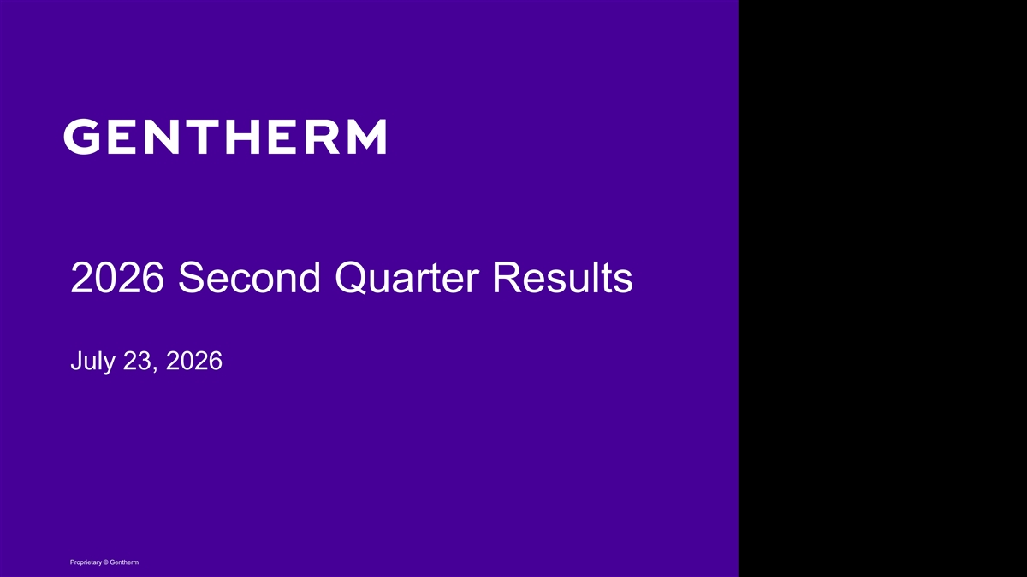
2026 Second Quarter Results July 23, 2026 Proprietary © Gentherm

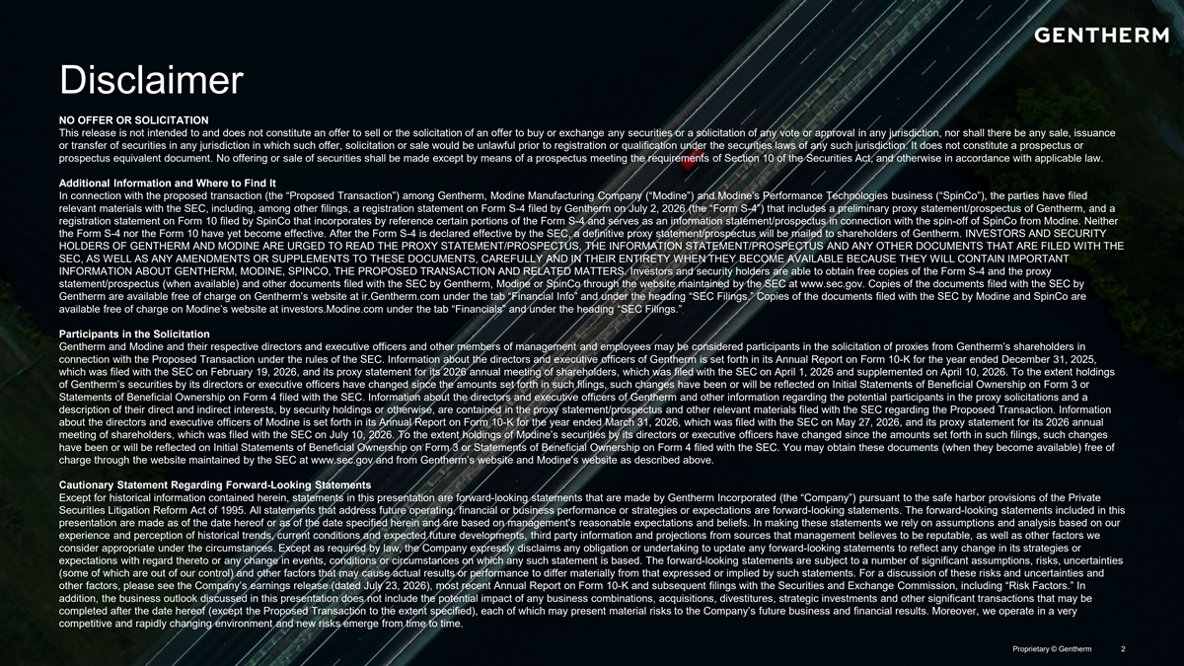
Disclaimer NO OFFER OR SOLICITATION This release is not intended to and does not constitute an offer to sell or the solicitation of an offer to buy or exchange any securities or a solicitation of any vote or approval in any jurisdiction, nor shall there be any sale, issuance or transfer of securities in any jurisdiction in which such offer, solicitation or sale would be unlawful prior to registration or qualification under the securities laws of any such jurisdiction. It does not constitute a prospectus or prospectus equivalent document. No offering or sale of securities shall be made except by means of a prospectus meeting the requirements of Section 10 of the Securities Act, and otherwise in accordance with applicable law. Additional Information and Where to Find It In connection with the proposed transaction (the “Proposed Transaction”) among Gentherm, Modine Manufacturing Company (“Modine”) and Modine’s Performance Technologies business (“SpinCo”), the parties have filed relevant materials with the SEC, including, among other filings, a registration statement on Form S-4 filed by Gentherm on July 2, 2026 (the “Form S-4”) that includes a preliminary proxy statement/prospectus of Gentherm, and a registration statement on Form 10 filed by SpinCo that incorporates by reference certain portions of the Form S-4 and serves as an information statement/prospectus in connection with the spin-off of SpinCo from Modine. Neither the Form S-4 nor the Form 10 have yet become effective. After the Form S-4 is declared effective by the SEC, a definitive proxy statement/prospectus will be mailed to shareholders of Gentherm. INVESTORS AND SECURITY HOLDERS OF GENTHERM AND MODINE ARE URGED TO READ THE PROXY STATEMENT/PROSPECTUS, THE INFORMATION STATEMENT/PROSPECTUS AND ANY OTHER DOCUMENTS THAT ARE FILED WITH THE SEC, AS WELL AS ANY AMENDMENTS OR SUPPLEMENTS TO THESE DOCUMENTS, CAREFULLY AND IN THEIR ENTIRETY WHEN THEY BECOME AVAILABLE BECAUSE THEY WILL CONTAIN IMPORTANT INFORMATION ABOUT GENTHERM, MODINE, SPINCO, THE PROPOSED TRANSACTION AND RELATED MATTERS. Investors and security holders are able to obtain free copies of the Form S-4 and the proxy statement/prospectus (when available) and other documents filed with the SEC by Gentherm, Modine or SpinCo through the website maintained by the SEC at www.sec.gov. Copies of the documents filed with the SEC by Gentherm are available free of charge on Gentherm’s website at ir.Gentherm.com under the tab “Financial Info” and under the heading “SEC Filings.” Copies of the documents filed with the SEC by Modine and SpinCo are available free of charge on Modine’s website at investors.Modine.com under the tab “Financials” and under the heading “SEC Filings.” Participants in the Solicitation Gentherm and Modine and their respective directors and executive officers and other members of management and employees may be considered participants in the solicitation of proxies from Gentherm’s shareholders in connection with the Proposed Transaction under the rules of the SEC. Information about the directors and executive officers of Gentherm is set forth in its Annual Report on Form 10-K for the year ended December 31, 2025, which was filed with the SEC on February 19, 2026, and its proxy statement for its 2026 annual meeting of shareholders, which was filed with the SEC on April 1, 2026 and supplemented on April 10, 2026. To the extent holdings of Gentherm’s securities by its directors or executive officers have changed since the amounts set forth in such filings, such changes have been or will be reflected on Initial Statements of Beneficial Ownership on Form 3 or Statements of Beneficial Ownership on Form 4 filed with the SEC. Information about the directors and executive officers of Gentherm and other information regarding the potential participants in the proxy solicitations and a description of their direct and indirect interests, by security holdings or otherwise, are contained in the proxy statement/prospectus and other relevant materials filed with the SEC regarding the Proposed Transaction. Information about the directors and executive officers of Modine is set forth in its Annual Report on Form 10-K for the year ended March 31, 2026, which was filed with the SEC on May 27, 2026, and its proxy statement for its 2026 annual meeting of shareholders, which was filed with the SEC on July 10, 2026. To the extent holdings of Modine’s securities by its directors or executive officers have changed since the amounts set forth in such filings, such changes have been or will be reflected on Initial Statements of Beneficial Ownership on Form 3 or Statements of Beneficial Ownership on Form 4 filed with the SEC. You may obtain these documents (when they become available) free of charge through the website maintained by the SEC at www.sec.gov and from Gentherm’s website and Modine’s website as described above. Cautionary Statement Regarding Forward-Looking Statements Except for historical information contained herein, statements in this presentation are forward-looking statements that are made by Gentherm Incorporated (the “Company”) pursuant to the safe harbor provisions of the Private Securities Litigation Reform Act of 1995. All statements that address future operating, financial or business performance or strategies or expectations are forward-looking statements. The forward-looking statements included in this presentation are made as of the date hereof or as of the date specified herein and are based on management's reasonable expectations and beliefs. In making these statements we rely on assumptions and analysis based on our experience and perception of historical trends, current conditions and expected future developments, third party information and projections from sources that management believes to be reputable, as well as other factors we consider appropriate under the circumstances. Except as required by law, the Company expressly disclaims any obligation or undertaking to update any forward-looking statements to reflect any change in its strategies or expectations with regard thereto or any change in events, conditions or circumstances on which any such statement is based. The forward-looking statements are subject to a number of significant assumptions, risks, uncertainties (some of which are out of our control) and other factors that may cause actual results or performance to differ materially from that expressed or implied by such statements. For a discussion of these risks and uncertainties and other factors, please see the Company’s earnings release (dated July 23, 2026), most recent Annual Report on Form 10-K and subsequent filings with the Securities and Exchange Commission, including “Risk Factors.” In addition, the business outlook discussed in this presentation does not include the potential impact of any business combinations, acquisitions, divestitures, strategic investments and other significant transactions that may be completed after the date hereof (except the Proposed Transaction to the extent specified), each of which may present material risks to the Company’s future business and financial results. Moreover, we operate in a very competitive and rapidly changing environment and new risks emerge from time to time. Proprietary © Gentherm 2

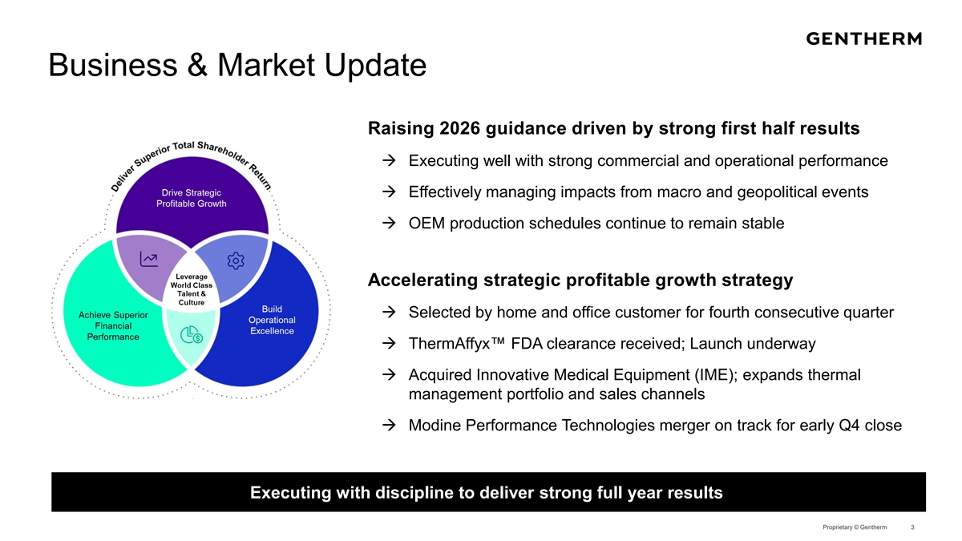
Business & Market Update Raising 2026 guidance driven by strong first half results à Executing well with strong commercial and operational performance à Effectively managing impacts from macro and geopolitical events à OEM production schedules continue to remain stable Accelerating strategic profitable growth strategy à Selected by home and office customer for fourth consecutive quarter à ThermAffyx FDA clearance received; Launch underway à Acquired Innovative Medical Equipment (IME); expands thermal management portfolio and sales channels à Modine Performance Technologies merger on track for early Q4 close Executing with discipline to deliver strong full year results Proprietary © Gentherm 3

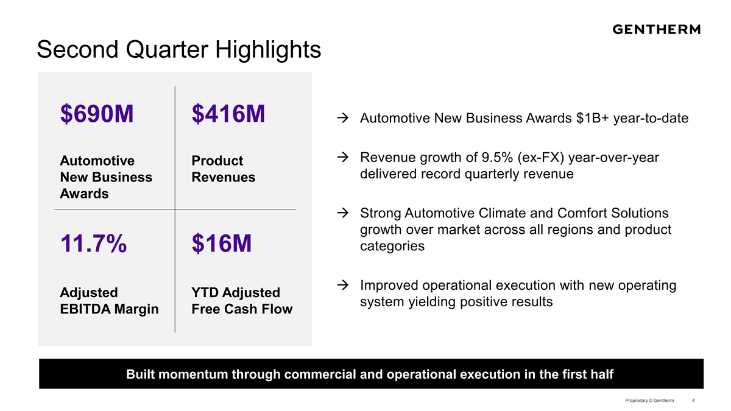
Second Quarter Highlights $690M $416Mà Automotive New Business Awards $1B+ year-to-date à Revenue growth of 9.5% (ex-FX) year-over-year Automotive Product delivered record quarterly revenue New Business Revenues Awards à Strong Automotive Climate and Comfort Solutions growth over market across all regions and product categories 11.7% $16M à Improved operational execution with new operating Adjusted YTD Adjusted system yielding positive results EBITDA Margin Free Cash Flow Built momentum through commercial and operational execution in the first half Proprietary © Gentherm 4

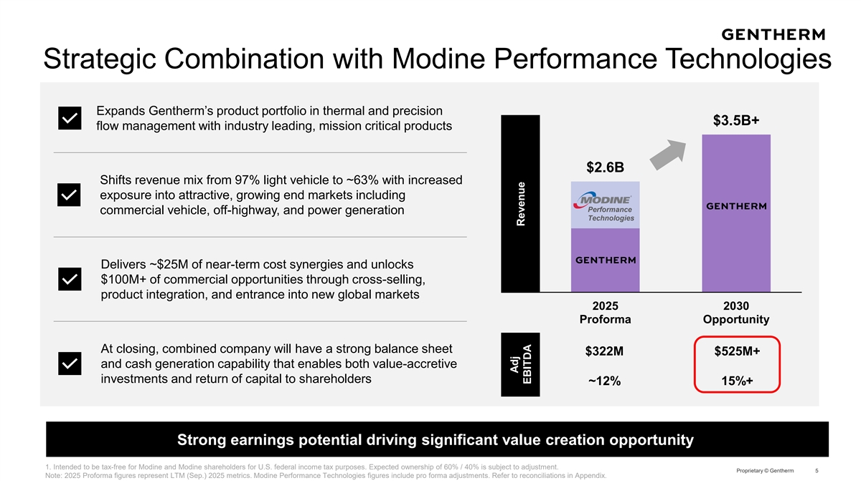
Strategic Combination with Modine Performance Technologies Expands Gentherm’s product portfolio in thermal and precision $3.5B+ flow management with industry leading, mission critical products $2.6B Shifts revenue mix from 97% light vehicle to ~63% with increased exposure into attractive, growing end markets including Performance commercial vehicle, off-highway, and power generation Technologies Delivers ~$25M of near-term cost synergies and unlocks $100M+ of commercial opportunities through cross-selling, product integration, and entrance into new global markets 2025 2030 Proforma Opportunity At closing, combined company will have a strong balance sheet $322M $525M+ and cash generation capability that enables both value-accretive investments and return of capital to shareholders ~12% 15%+ Strong earnings potential driving significant value creation opportunity 1. Intended to be tax-free for Modine and Modine shareholders for U.S. federal income tax purposes. Expected ownership of 60% / 40% is subject to adjustment. Proprietary © Gentherm 5 Note: 2025 Proforma figures represent LTM (Sep.) 2025 metrics. Modine Performance Technologies figures include pro forma adjustments. Refer to reconciliations in Appendix. Adj Revenue EBITDA

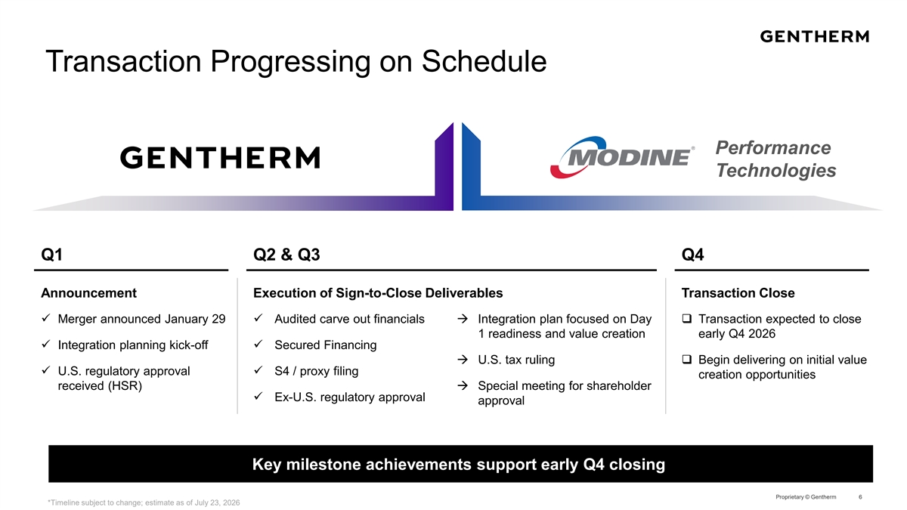
Transaction Progressing on Schedule Performance Technologies Q1 Q2 & Q3 Q4 Announcement Execution of Sign-to-Close Deliverables Transaction Close ü Merger announced January 29ü Audited carve out financialsà Integration plan focused on Day q Transaction expected to close 1 readiness and value creation early Q4 2026 ü Integration planning kick-offü Secured Financing à U.S. tax rulingq Begin delivering on initial value ü U.S. regulatory approval ü S4 / proxy filing creation opportunities received (HSR)à Special meeting for shareholder ü Ex-U.S. regulatory approval approval Key milestone achievements support early Q4 closing Proprietary © Gentherm 6 *Timeline subject to change; estimate as of July 23, 2026

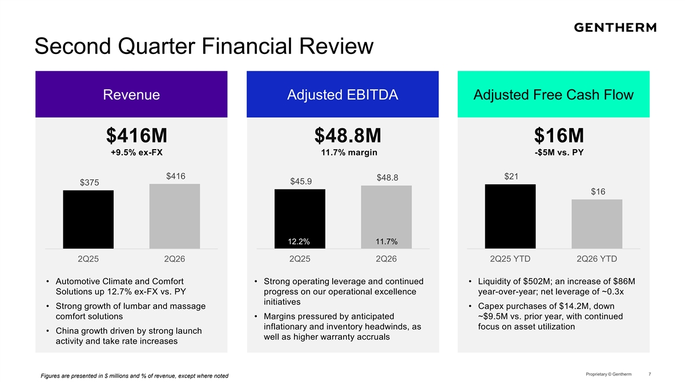
Second Quarter Financial Review Revenue Adjusted EBITDA Adjusted Free Cash Flow $416M $48.8M $16M +9.5% ex-FX 11.7% margin -$5M vs. PY $416 $21 $48.8 $45.9 $375 $16 12.2% 11.7% 2Q25 2Q26 2Q25 2Q26 2Q25 YTD 2Q26 YTD • Automotive Climate and Comfort • Strong operating leverage and continued • Liquidity of $502M; an increase of $86M Solutions up 12.7% ex-FX vs. PY progress on our operational excellence year-over-year; net leverage of ~0.3x initiatives • Strong growth of lumbar and massage • Capex purchases of $14.2M, down comfort solutions • Margins pressured by anticipated ~$9.5M vs. prior year, with continued inflationary and inventory headwinds, as focus on asset utilization • China growth driven by strong launch well as higher warranty accruals activity and take rate increases Proprietary © Gentherm 7 Figures are presented in $ millions and % of revenue, except where noted

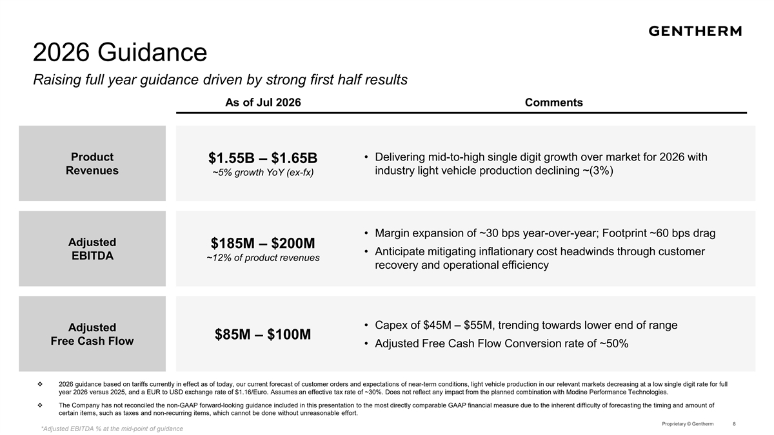
2026 Guidance Raising full year guidance driven by strong first half results As of Jul 2026 Comments Product • Delivering mid-to-high single digit growth over market for 2026 with $1.55B – $1.65B Revenues industry light vehicle production declining ~(3%) ~5% growth YoY (ex-fx) • Margin expansion of ~30 bps year-over-year; Footprint ~60 bps drag Adjusted $185M – $200M • Anticipate mitigating inflationary cost headwinds through customer EBITDA ~12% of product revenues recovery and operational efficiency • Capex of $45M – $55M, trending towards lower end of range Adjusted $85M – $100M Free Cash Flow • Adjusted Free Cash Flow Conversion rate of ~50% v 2026 guidance based on tariffs currently in effect as of today, our current forecast of customer orders and expectations of near-term conditions, light vehicle production in our relevant markets decreasing at a low single digit rate for full year 2026 versus 2025, and a EUR to USD exchange rate of $1.16/Euro. Assumes an effective tax rate of ~30%. Does not reflect any impact from the planned combination with Modine Performance Technologies. v The Company has not reconciled the non-GAAP forward-looking guidance included in this presentation to the most directly comparable GAAP financial measure due to the inherent difficulty of forecasting the timing and amount of certain items, such as taxes and non-recurring items, which cannot be done without unreasonable effort. Proprietary © Gentherm 8 *Adjusted EBITDA % at the mid-point of guidance

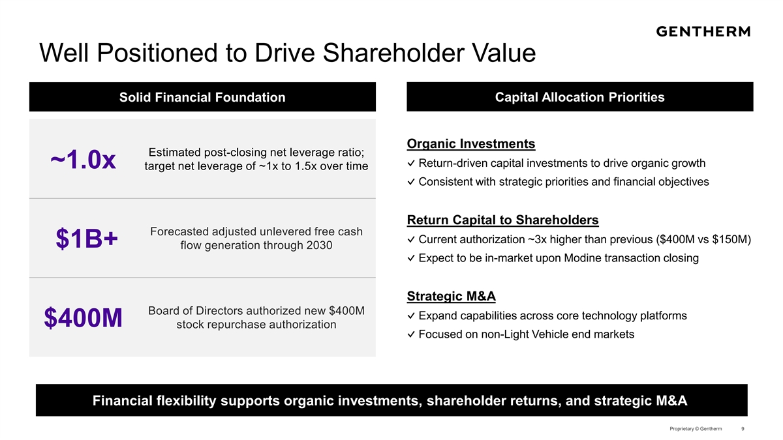
Well Positioned to Drive Shareholder Value Solid Financial Foundation Capital Allocation Priorities Organic Investments Estimated post-closing net leverage ratio; ✓ Return-driven capital investments to drive organic growth ~1.0x target net leverage of ~1x to 1.5x over time ✓ Consistent with strategic priorities and financial objectives Return Capital to Shareholders Forecasted adjusted unlevered free cash ✓ Current authorization ~3x higher than previous ($400M vs $150M) $1B+ flow generation through 2030 ✓ Expect to be in-market upon Modine transaction closing Strategic M&A Board of Directors authorized new $400M ✓ Expand capabilities across core technology platforms $400M stock repurchase authorization ✓ Focused on non-Light Vehicle end markets Financial flexibility supports organic investments, shareholder returns, and strategic M&A Proprietary © Gentherm 9

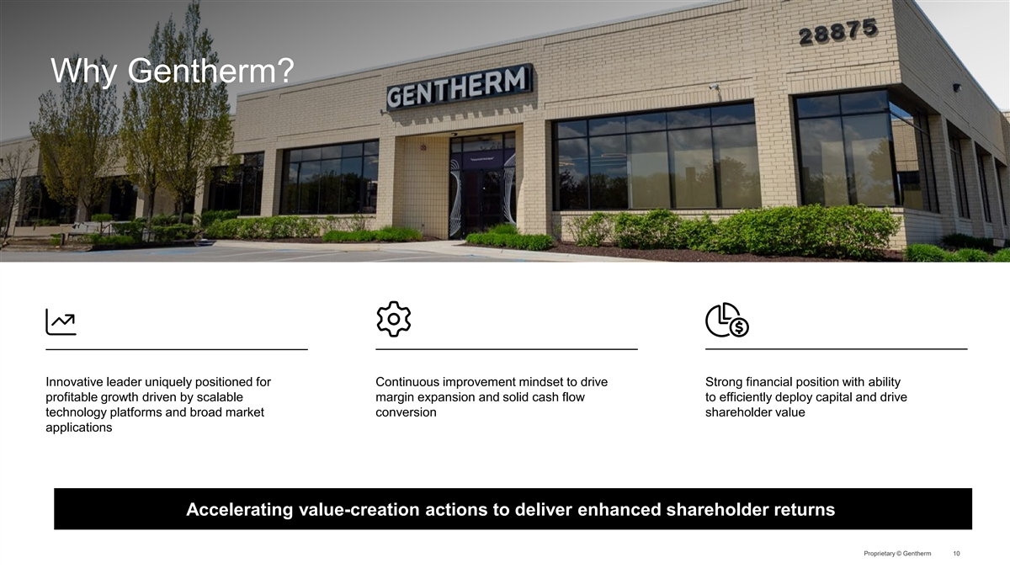
Why Gentherm? Innovative leader uniquely positioned for Continuous improvement mindset to drive Strong financial position with ability profitable growth driven by scalable margin expansion and solid cash flow to efficiently deploy capital and drive technology platforms and broad market conversion shareholder value applications Accelerating value-creation actions to deliver enhanced shareholder returns Proprietary © Gentherm 10


Appendix Proprietary © Gentherm

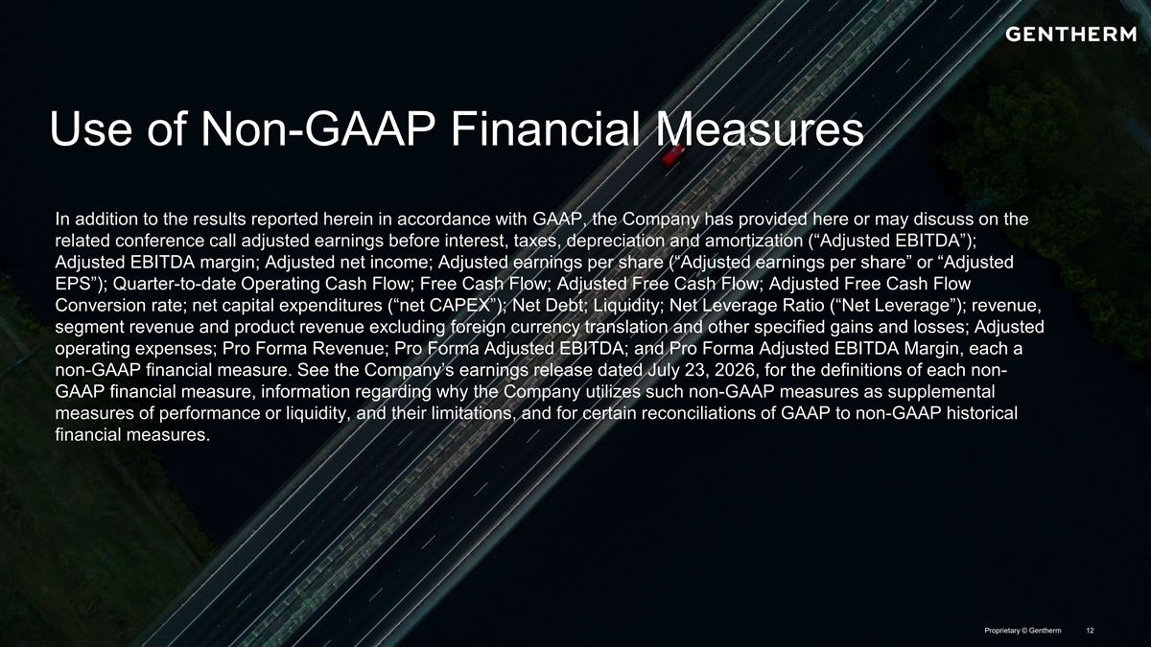
Use of Non-GAAP Financial Measures In addition to the results reported herein in accordance with GAAP, the Company has provided here or may discuss on the related conference call adjusted earnings before interest, taxes, depreciation and amortization (“Adjusted EBITDA”); Adjusted EBITDA margin; Adjusted net income; Adjusted earnings per share (“Adjusted earnings per share” or “Adjusted EPS”); Quarter-to-date Operating Cash Flow; Free Cash Flow; Adjusted Free Cash Flow; Adjusted Free Cash Flow Conversion rate; net capital expenditures (“net CAPEX”); Net Debt; Liquidity; Net Leverage Ratio (“Net Leverage”); revenue, segment revenue and product revenue excluding foreign currency translation and other specified gains and losses; Adjusted operating expenses; Pro Forma Revenue; Pro Forma Adjusted EBITDA; and Pro Forma Adjusted EBITDA Margin, each a non-GAAP financial measure. See the Company’s earnings release dated July 23, 2026, for the definitions of each non- GAAP financial measure, information regarding why the Company utilizes such non-GAAP measures as supplemental measures of performance or liquidity, and their limitations, and for certain reconciliations of GAAP to non-GAAP historical financial measures. Proprietary © Gentherm 12

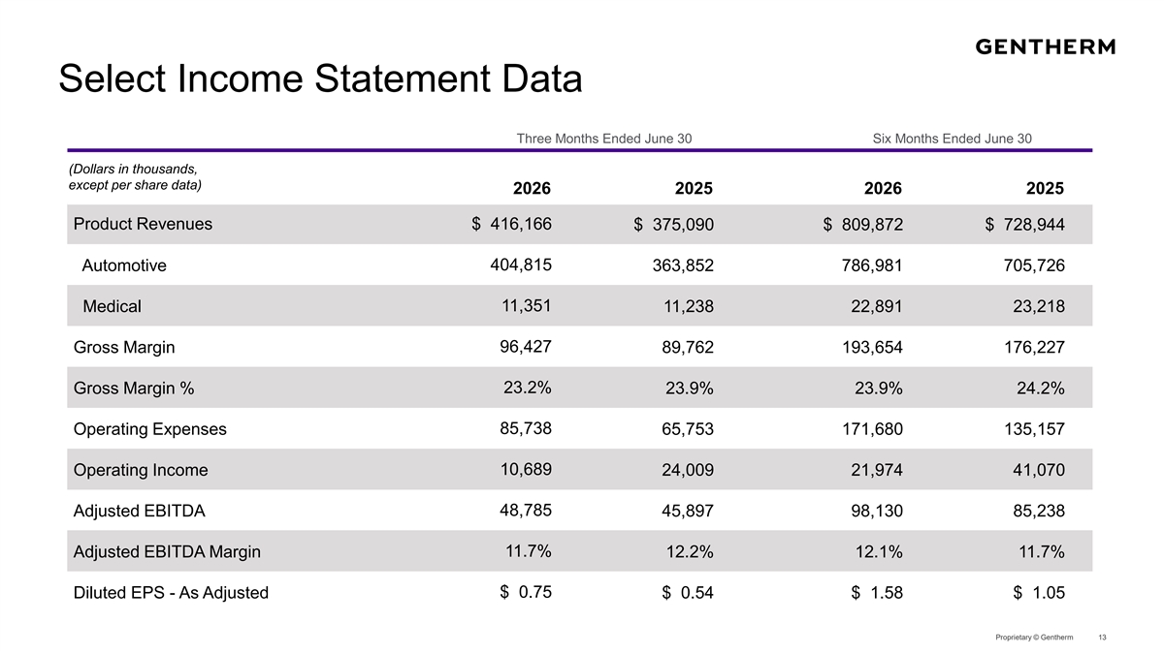
Select Income Statement Data Three Months Ended June 30 Six Months Ended June 30 (Dollars in thousands, except per share data) 2026 2025 2026 2025 Product Revenues $ 416,166 $ 375,090 $ 809,872 $ 728,944 404,815 Automotive 363,852 786,981 705,726 11,351 Medical 11,238 22,891 23,218 96,427 Gross Margin 89,762 193,654 176,227 Gross Margin % 23.2% 23.9% 23.9% 24.2% Operating Expenses 85,738 65,753 171,680 135,157 10,689 Operating Income 24,009 21,974 41,070 48,785 Adjusted EBITDA 45,897 98,130 85,238 Adjusted EBITDA Margin 11.7% 12.2% 12.1% 11.7% Diluted EPS - As Adjusted $ 0.75 $ 0.54 $ 1.58 $ 1.05 Proprietary © Gentherm 13

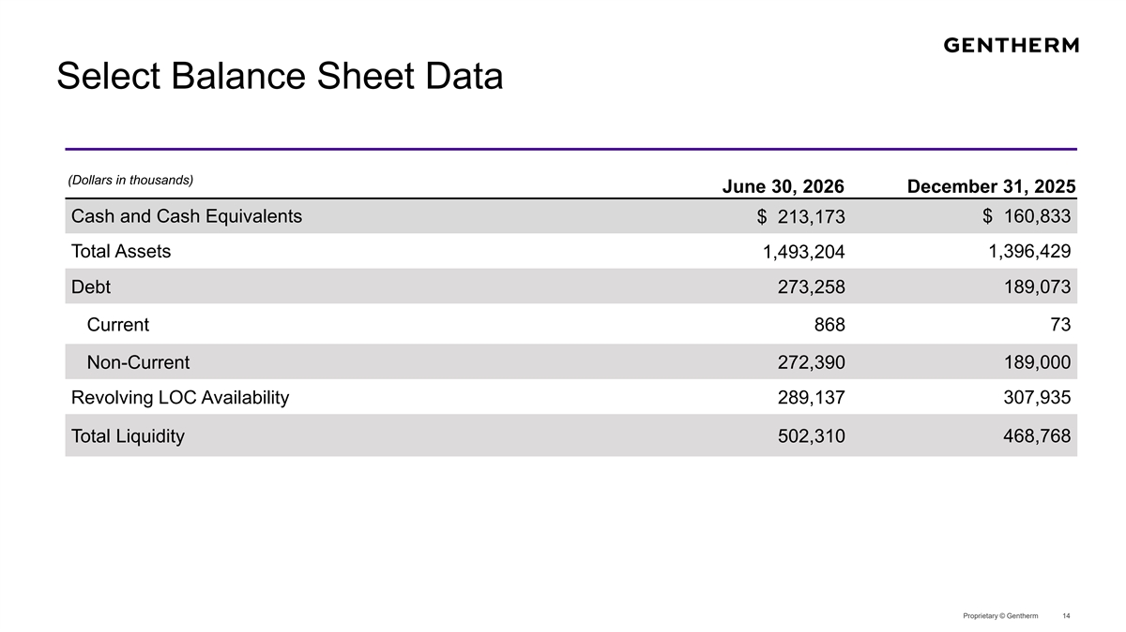
Select Balance Sheet Data (Dollars in thousands) June 30, 2026 December 31, 2025 Cash and Cash Equivalents $ 160,833 $ 213,173 Total Assets 1,396,429 1,493,204 Debt 273,258 189,073 Current 868 73 Non-Current 272,390 189,000 Revolving LOC Availability 289,137 307,935 Total Liquidity 502,310 468,768 Proprietary © Gentherm 14

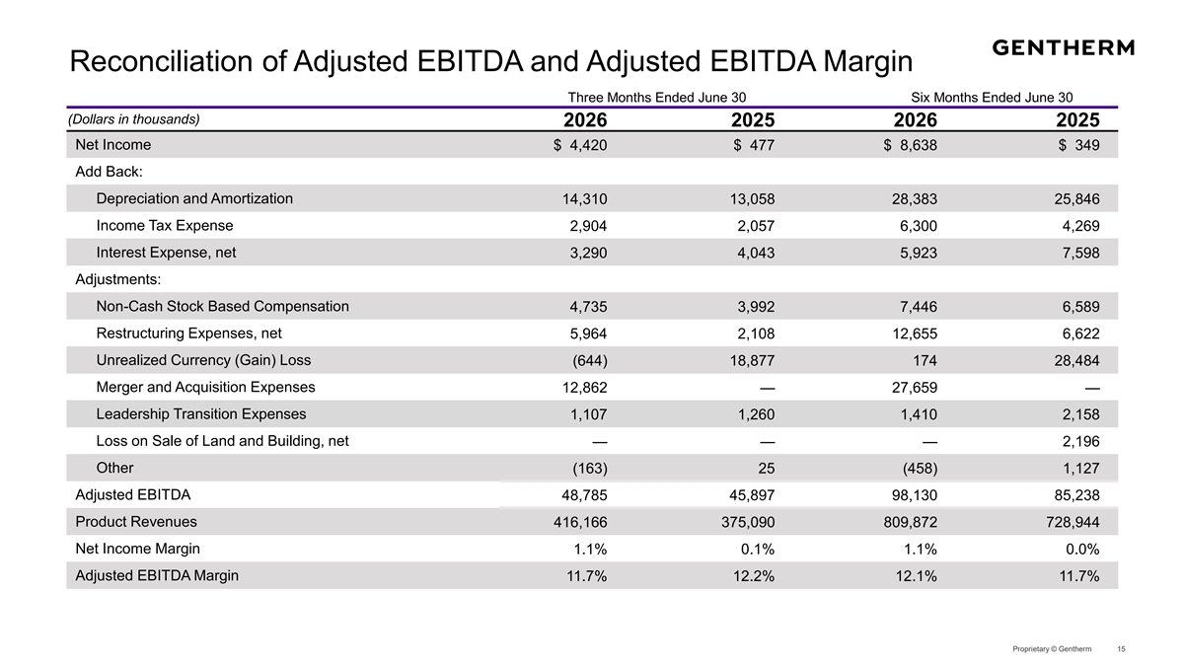
Reconciliation of Adjusted EBITDA and Adjusted EBITDA Margin Three Months Ended June 30 Six Months Ended June 30 (Dollars in thousands) 2026 2025 2026 2025 Net Income $ 4,420 $ 477 $ 8,638 $ 349 Add Back: Depreciation and Amortization 14,310 13,058 28,383 25,846 Income Tax Expense 2,904 2,057 6,300 4,269 Interest Expense, net 3,290 4,043 5,923 7,598 Adjustments: Non-Cash Stock Based Compensation 4,735 3,992 7,446 6,589 Restructuring Expenses, net 5,964 2,108 12,655 6,622 Unrealized Currency (Gain) Loss (644) 18,877 174 28,484 Merger and Acquisition Expenses 12,862 — 27,659 — Leadership Transition Expenses 1,107 1,260 1,410 2,158 Loss on Sale of Land and Building, net — — — 2,196 Other (163) 25 (458) 1,127 Adjusted EBITDA 48,785 45,897 98,130 85,238 Product Revenues 416,166 375,090 809,872 728,944 Net Income Margin 1.1% 0.1% 1.1% 0.0% Adjusted EBITDA Margin 11.7% 12.2% 12.1% 11.7% Proprietary © Gentherm 15

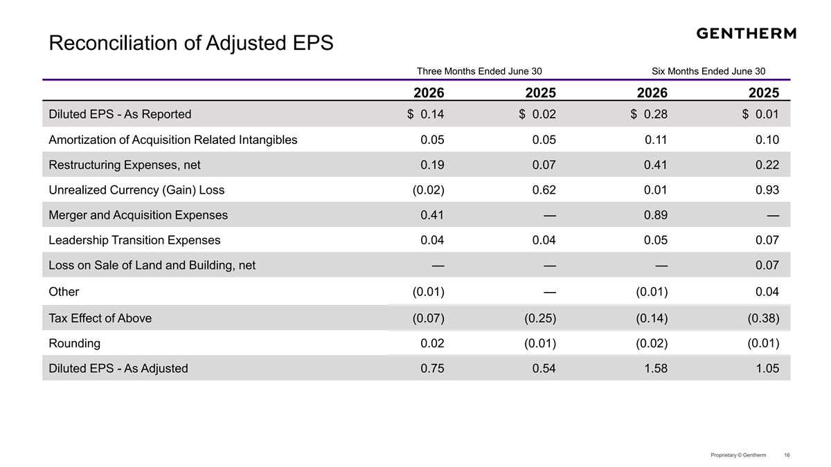
Reconciliation of Adjusted EPS Three Months Ended June 30 Six Months Ended June 30 2026 2025 2026 2025 Diluted EPS - As Reported $ 0.14 $ 0.02 $ 0.28 $ 0.01 Amortization of Acquisition Related Intangibles 0.05 0.05 0.11 0.10 Restructuring Expenses, net 0.19 0.07 0.41 0.22 Unrealized Currency (Gain) Loss (0.02) 0.62 0.01 0.93 Merger and Acquisition Expenses 0.41 — 0.89 — Leadership Transition Expenses 0.04 0.04 0.05 0.07 Loss on Sale of Land and Building, net — — — 0.07 Other (0.01) — (0.01) 0.04 Tax Effect of Above (0.07) (0.25) (0.14) (0.38) Rounding 0.02 (0.01) (0.02) (0.01) Diluted EPS - As Adjusted 0.75 0.54 1.58 1.05 Proprietary © Gentherm 16

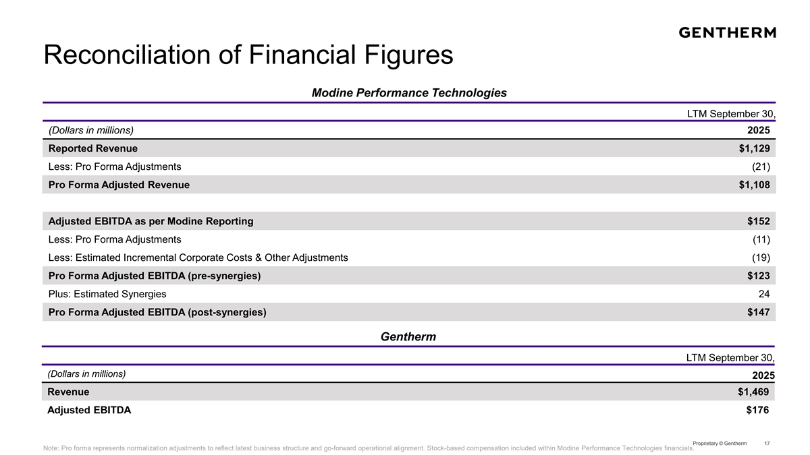
Reconciliation of Financial Figures Modine Performance Technologies LTM September 30, (Dollars in millions) 2025 Reported Revenue $1,129 Less: Pro Forma Adjustments (21) Pro Forma Adjusted Revenue $1,108 Adjusted EBITDA as per Modine Reporting $152 Less: Pro Forma Adjustments (11) Less: Estimated Incremental Corporate Costs & Other Adjustments (19) Pro Forma Adjusted EBITDA (pre-synergies) $123 Plus: Estimated Synergies 24 Pro Forma Adjusted EBITDA (post-synergies) $147 Gentherm LTM September 30, (Dollars in millions) 2025 Revenue $1,469 Adjusted EBITDA $176 Proprietary © Gentherm 17 Note: Pro forma represents normalization adjustments to reflect latest business structure and go-forward operational alignment. Stock-based compensation included within Modine Performance Technologies financials.

